**AUGMENTED REALITY**

Technology has touched all aspects of our lives. Technology has had a huge impact on the quality of life that we lead in the modern age. From educational sector to healthcare sector all sectors benefitted hugely due to the advancement in technology. A lot of technologies have been used in these sectors. Augmented Reality is one such emerging technology that has huge promises. Augmented Reality is the real time direction of the existing reality and physical objects to trigger the enhancements over the reality, like images or 3D objects. AR is closer to the real-world objects. Basically, AR generates user selected images, videos, 3D objects and information into the real environment which can be viewed through the camera of the devices.

|  |
| --- |
| C:\Users\FARSAK\Desktop\Vuforia Article\Images\vid-still.jpg |

The best-known examples are BBC civilisations AR, Pokemon Go, IKEA replace and Sketchar. For example, Pokemon Go uses GPS to mark your location and move your in-game avatar, while your smartphone camera is used to show Pokémon in the real world. AR enhances the user’s perception of interaction with the real world. AR augments the user defined image target alongside the coordinates where next images, videos or objects can be transformed.

Vuforia is an Augmented Reality Software Development Kit for mobile devices to create AR applications. Vuforia has lots of funtions like 2D marker tracking, 3D object and model tracking, multi target tracking, text tracking, VuMark, cloud database based tracking and now ArCore and ARkit supports. Vuforia supports the Android, IOS and Universal Windows Platform Smart Glasses Hololens platforms and it has free and paid versions. Free version is limited for some functions and user amount; and $499 one-time fee or $99 for monthly for advanced funtions.

Now lets talk about Unity3D and then start a Vuforia project. Unity3D is one of the most popular game engine for amateur and professional developers and studios. Unity3D is orginally designed for 3D game making with de-facto standarts , low cost and easy of use, but after Unity 4.3, it is also possible to create 2D games and applications. Unity is very flexible and powerful for creation multiplatform games and applications. There are so many platforms that you can deploy to with the Unity3D like Android, IOS, Windows, Universal Windows Platfrom, Mac, Linux, WebGL, PlayStation 4, PSVita, Xbox, Nintendo, Oculus Rift and more. Unity is a “One code-based for all platforms” or “Build once Deploy Anywhere” game engine. It means, you can create the project ones and build to all platforms.

#### IMPLEMENTATION AUGMENTED REALITY IN UNITY3D WITH VUFORIA

**Before Starting**

* Before starting, you need a Vuforia Developer Account. From <https://developer.vuforia.com/vui/auth/register> register to free. If you have already an account, login to developer portal.
* If you use the last version of Vuforia SDK, you need version 2017.2 of Unity3D. If you don’t have this version or higher, you can download it <https://unity3d.com/get-unity/download>
* Now we need Vuforia SDK. (If you already have the SDK skip this step) If you don’t have Vuforia SDK and you use Unity version 2017.2 or higher you can install the SDK with using Unity Installer. You can get the installer here. <https://unity3d.com/get-unity/download/archive> Choose your Unity version and select the Unity Installer

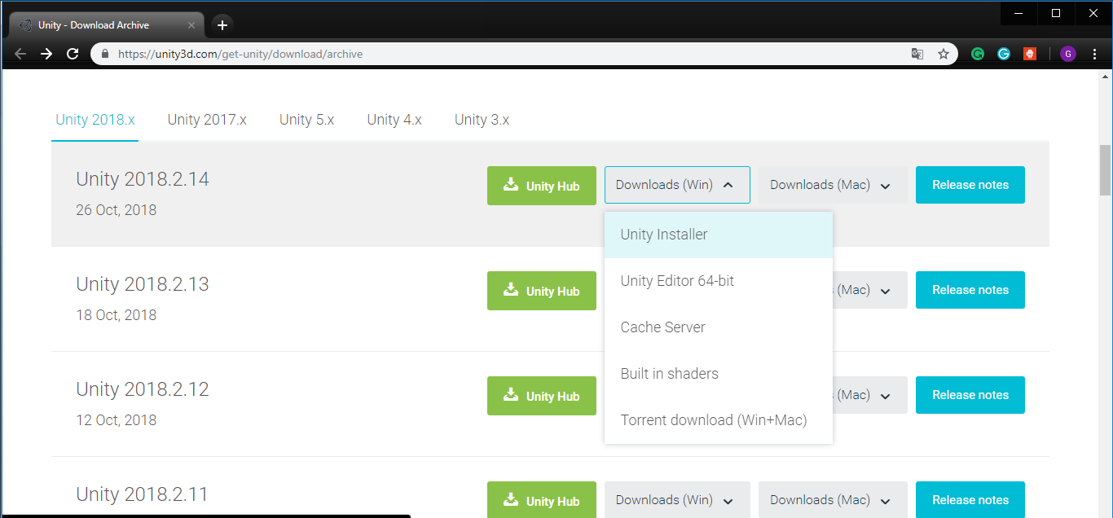

* Open the installer and choose components. We are going to make an app on Android platform so we need to Android Build Support. Also Vuforia Augmented Reality Support of course, dont forget it.

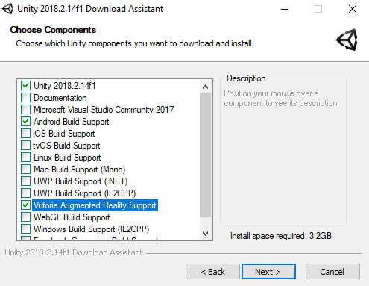

* If you use other version of Unity(lower than 2017.2) you need to download the Vuforia UnityPackage from here but we recommend downloading the latest version of Unity3D. <https://developer.vuforia.com/downloads/sdk?d=windows-30-16-4815&retU#downloadModal>

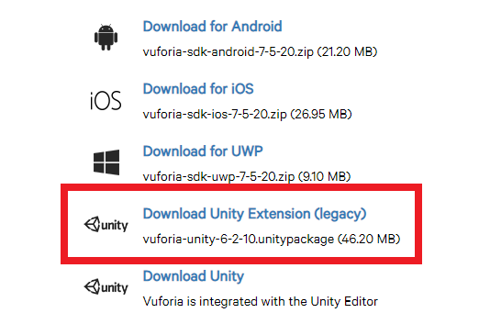



* If everything is fine lets open New Unity Project. Open Unity3D and click New button that is at the right top. And write your project name and choose the project location. Click CreateProject button to create the project and open it.

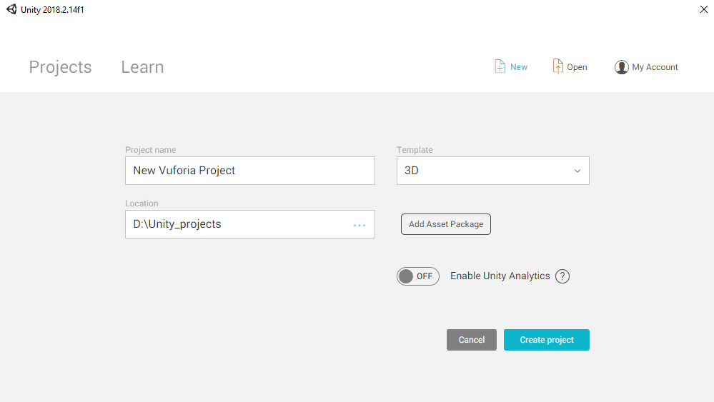

* After opening the project, we need to change some settings.
  + First of all is Platform. As I said Unity3D is a multi-platfotm game engine and you can build your project on so many platforms. We are developing a Android application so we need to change platform from PC to Android. Go “File > Build Settings” Select the Android option and click the Switch Platform. If you dont have Android Support Module, there will be a download option to download it but we did it at the beginning of installaiton using Download Asistant. (If you are new in Android platform, you also JDK and Android SDK to build Android. Go “Edit > Preferences > External tools” and set locations of these development kits).

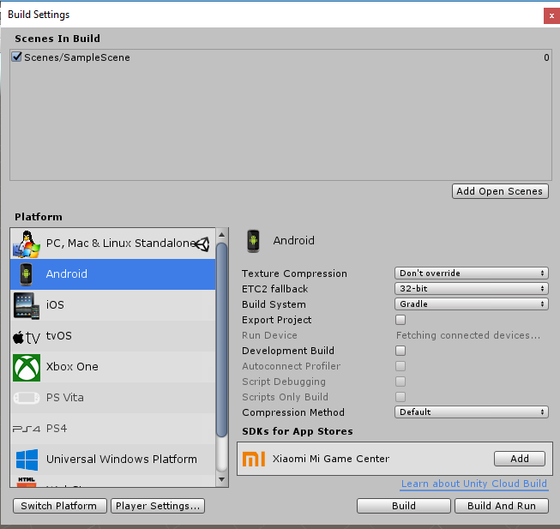

* + Second setting is Vuforia Support. Go “Edit > Project Settings > Playe” and check the Vuforia Support box under XR Settings.

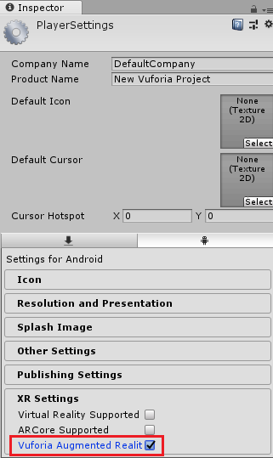

* Perfect, Finally we can start the developed our game. First we need “Development License Key”. It is free. Open the Vuforia Developer Console. (Login your account)

<https://developer.vuforia.com/targetmanager/licenseManager/licenseListing>

Click “Get Development Key”

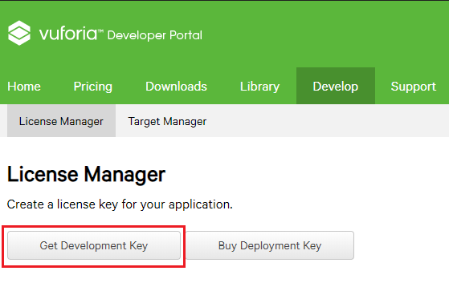

* Enter your Application name and Confirm

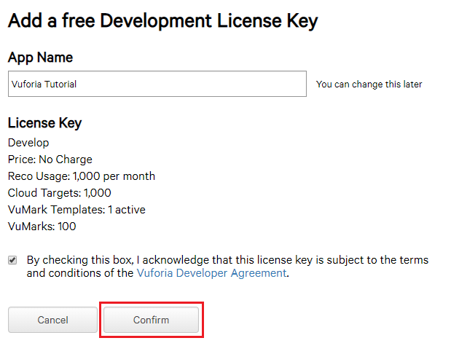

* Select your Application

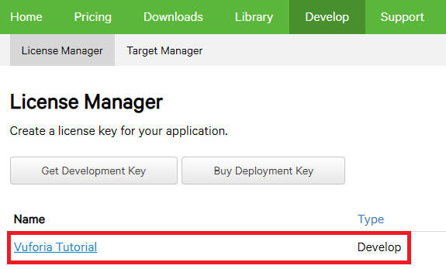

* Copy the licence key. We use this in Unity.

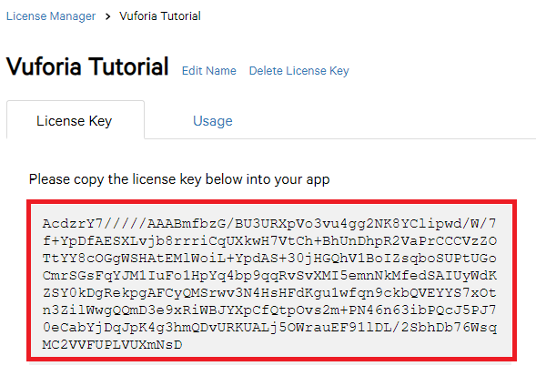

* Now go back to Unity and then Window -> Vuforia Configuraions (Ctrl + Shift + V) And paste the license key that you copied previous step.

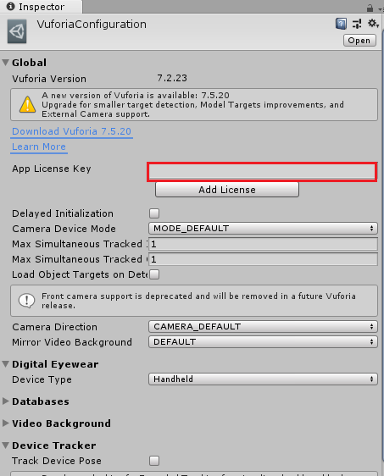

* Open the Vuforia Developer Portal again and go Target Manager to add images that are recognized by the application  
  <https://developer.vuforia.com/targetmanager/project/checkDeviceProjectsCreated>
* Click the “Add Database” to create a new Database

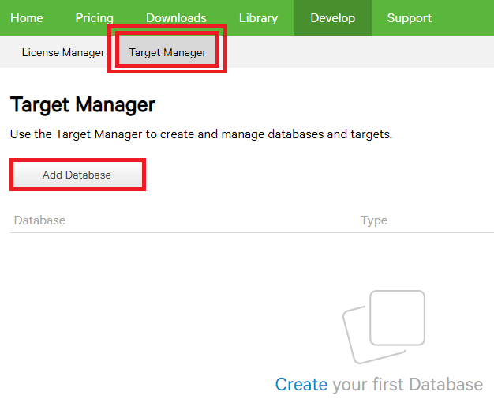

* Set the database name as that you want. And choose Device option

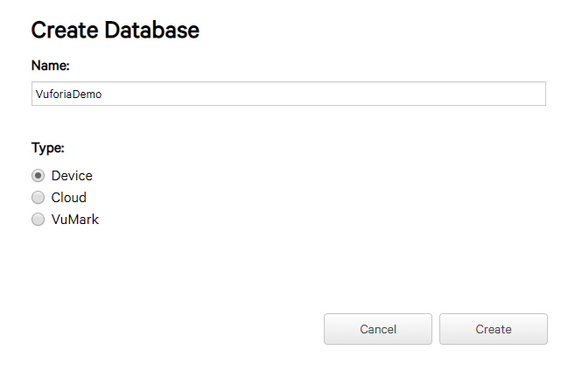

* Choose your database and click “Add Target”. Then Browse the image file. Format of the image must be .jpg or .png and it must be max 2mb.Set the width to 1 and if you want change the name. After all, click to “Add”

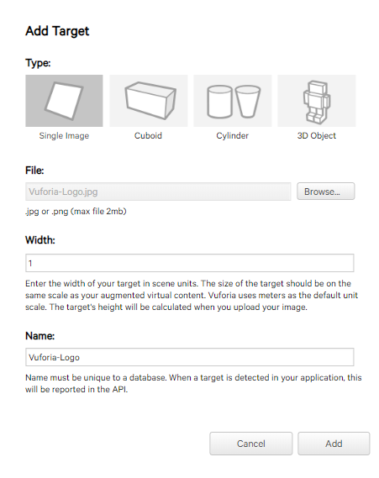

* Now time to download the database. Click “Download Database (All) or choose images that what you want to download.

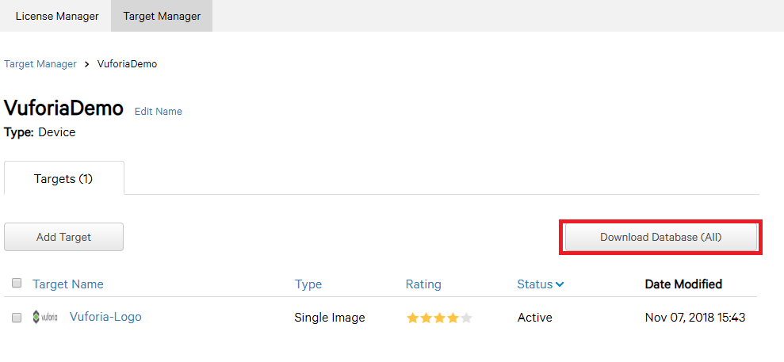

* Choose “Unity Editor” option to download as a UnityPackage

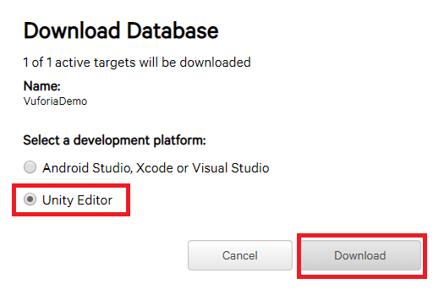

* An Unity Package file will downloaded. Click and open it or Go Unity and “Asset > Import Package > Custom Package and Select the downloaded package. Import all using Import Button

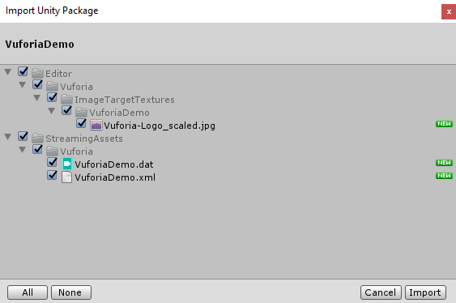

* Delete the Main Camera that in the scene. And then add a ARCamera to scene. GameObject->Vuforia->ARCamera

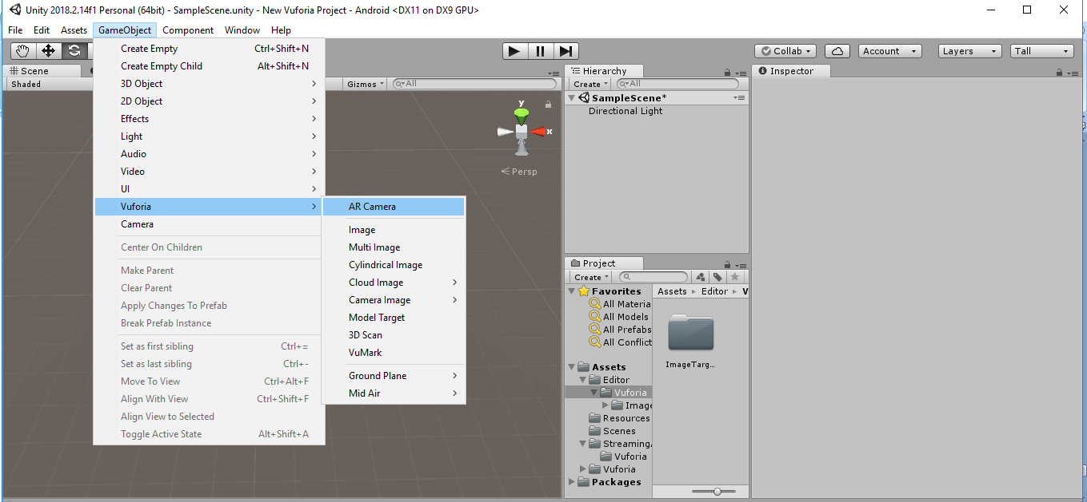

* And add an Image to scece

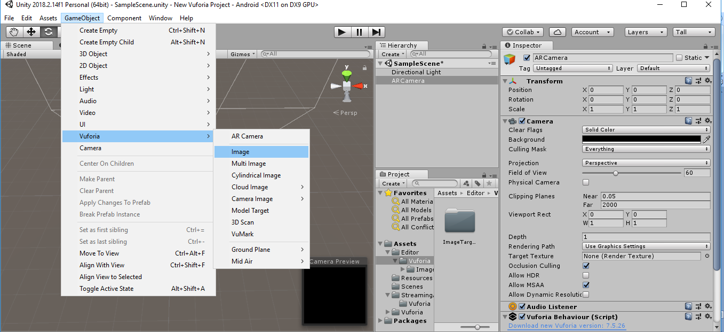

* Set the Image Target Behaviour Component of the image like this.
  + Type : Predefined
  + Database : VuforiaDemo (this would be your database name)
  + Image Target : Vuforia-Logo (This would be your image name that recognized by the camera)

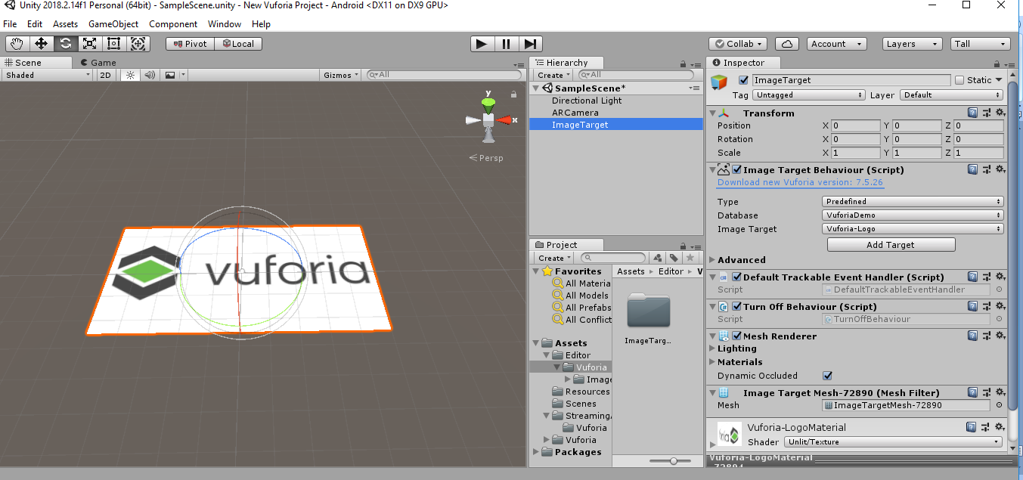

* Now add a Cube or something else that want to see when image recognized.

The object must be child of the image

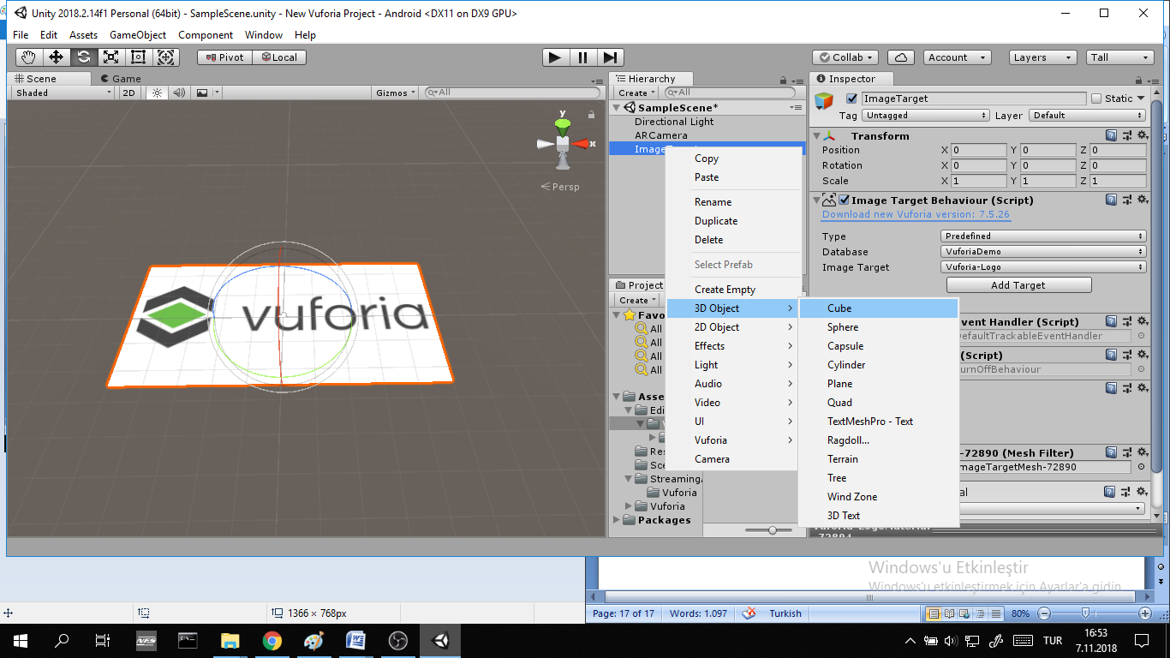

* + Scale and rotate as you want. This object will appear when image target recognized.

-Ready to Build

* Make your basic Unity build settings.Click the Build to create an apk.

GIFFFFF

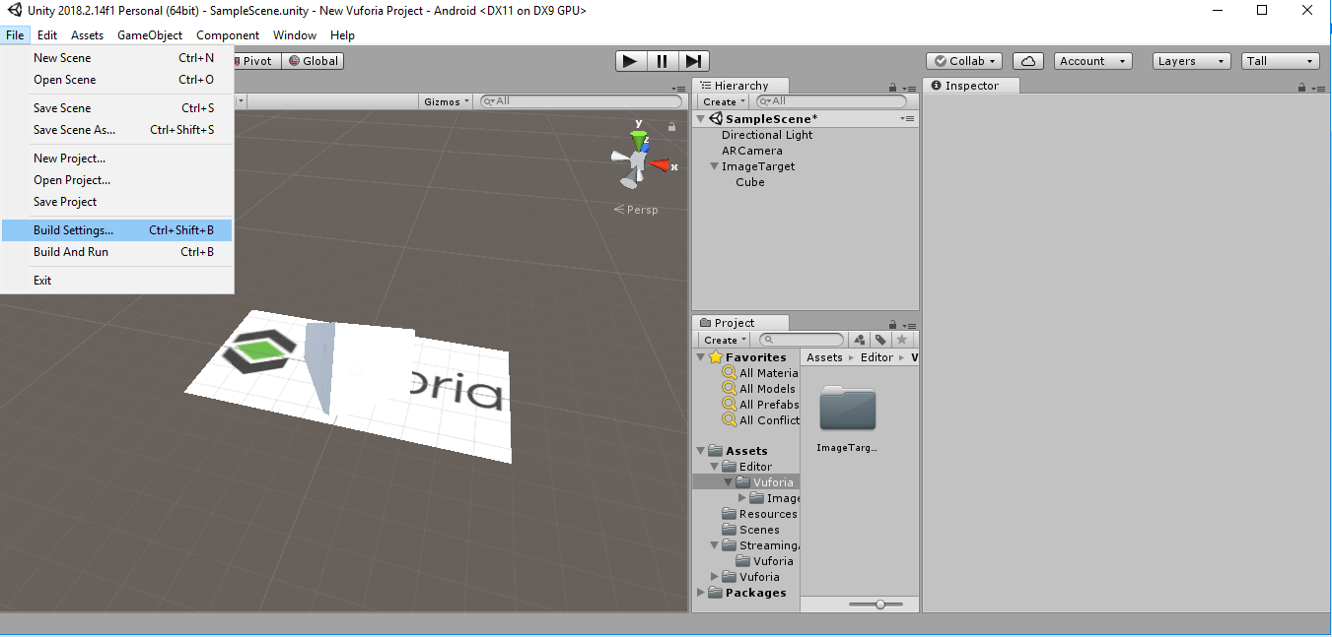

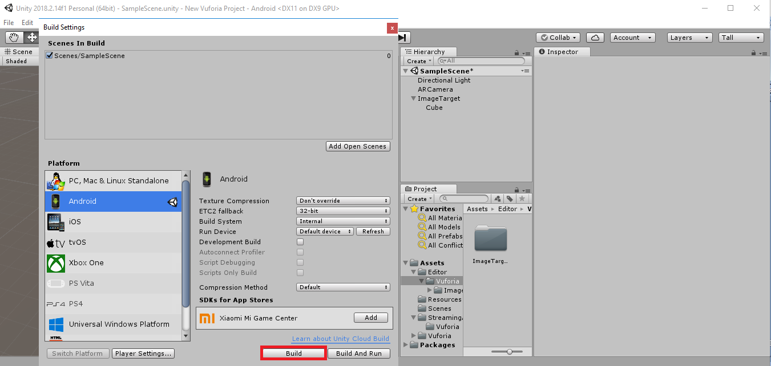

* Congratulation your first Augmented Reality App ready to run.